**Lab 3 Finite State Machine (FSM)**

**1 FSM Example**

* Modelsim: moore_110_detector.vhd, mealy_110_detector.vhd, testbench_101.vhd
* Result:

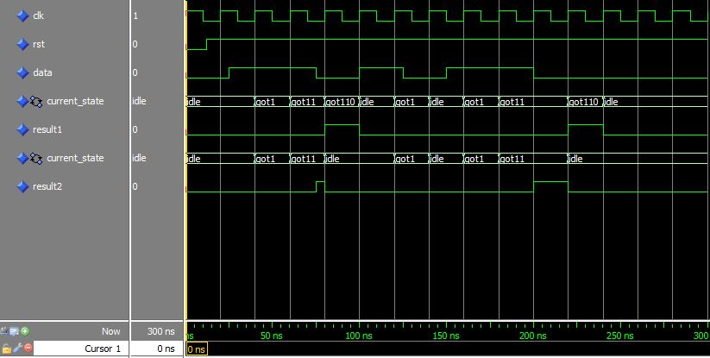

* Moore FSM

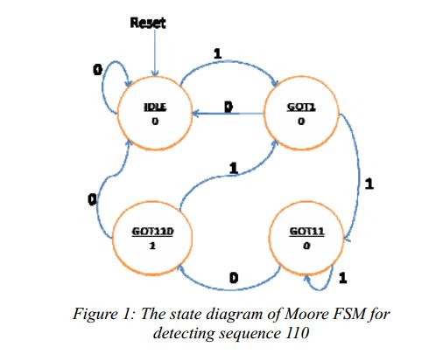

* Mealy FSM

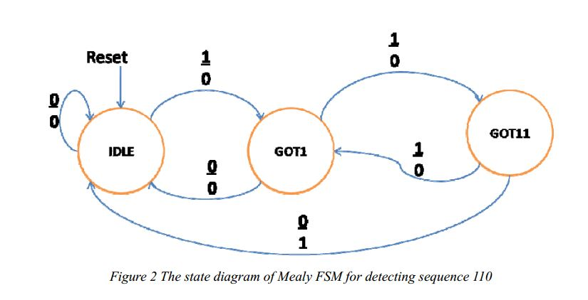

* From two figures above, we obtain:
* Mealy state machine reacts faster to inputs – don’t need to wait for clock.Outputs of Moore machine change at clock edge (always one cycle later)
* Mealy state machine requires less state than Moore machines. Mealy machine has only three state (IDLE, GOT1, GOT11) while Moore machine has four state (IDLE, GOT1, GOT11, GOT110)
* Outputs of the Mealy machine depend on both input and current state. In the above figure, output = 1 when current state = GOT11 and input = 0.

Outputs of the Moore machine just depend on current state. In the above figure, output = 1 when current state = GOT110 at rising edge of clock.

* Which state machine is better? Why?
* Mealy state machines are faster because their state is depend on the input. However, Moore machines are safer because they change states on the clock edge while in Mealy machines, input change can cause output change as soon as logic is done – a big problem when two machines are interconnected – asynchronous feedback may occur if one isn’t careful.

**2 Design a detertor**

* Modelsim: moore_101.vhd, mealy_101.vhd, testbench_101.vhd
* Result:

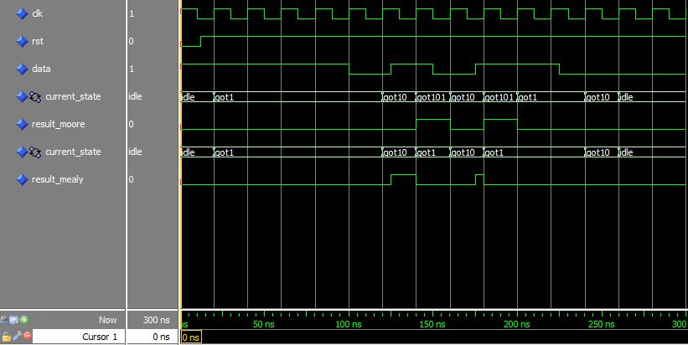

1

* Moore FSM diagram:

1

1

1

0

0

0

0

* Mealy FSM diagram

1/1

1/0

1/0

0/0

0/0

0/0